**Big Mountain’s Ideal Ticket Price**

The results of the Big Mountain resort ticket modeling support an increase in ticket prices.

As the model was refined the original mean absolute error of $19.14 was reduced to $9. This allows for more confidence in setting the magnitude of the ticket increase.

It was determined that a k value of 8 was the best fit for the model.

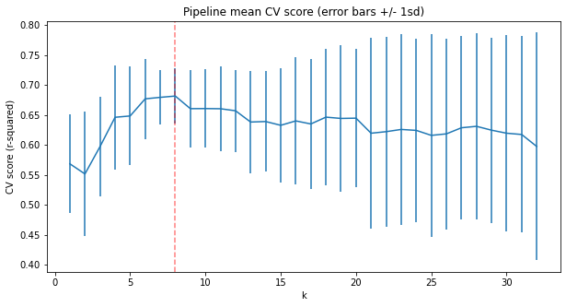

The top four features of a ski resort that drive ticket price in order of importance are fastQuads, Runs, Snow making capability and vertical drop. The other features have little to no impact on the value of the ticket. The ranking of importance is demonstrated in the exhibit below.

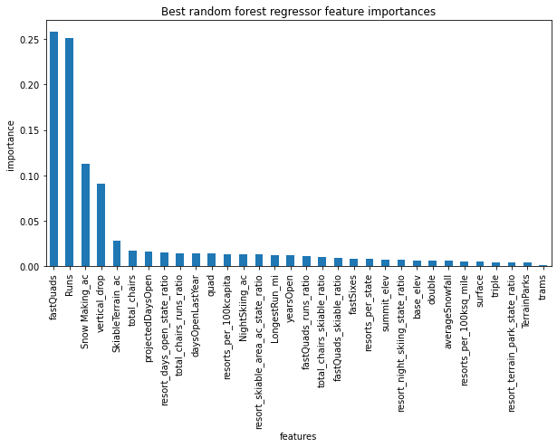

Big Mountain’s Market position in the top four features are modeled below.

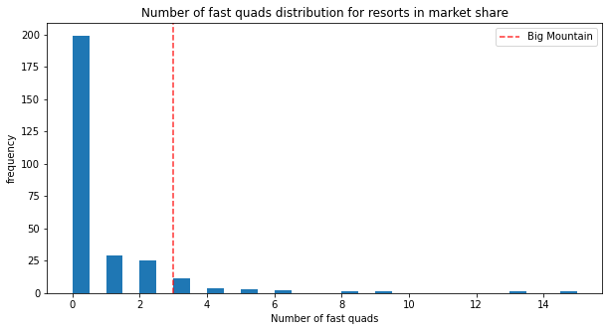

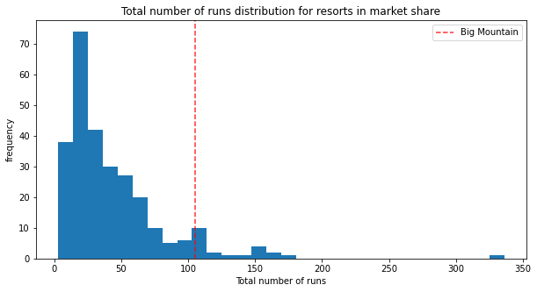

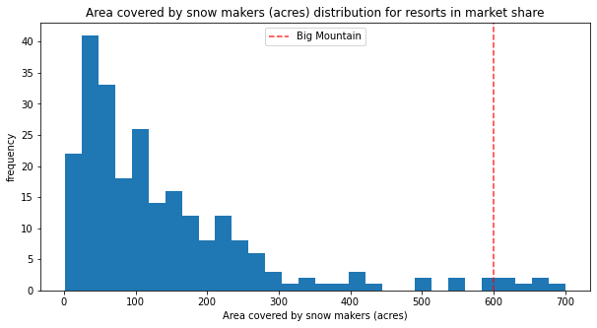

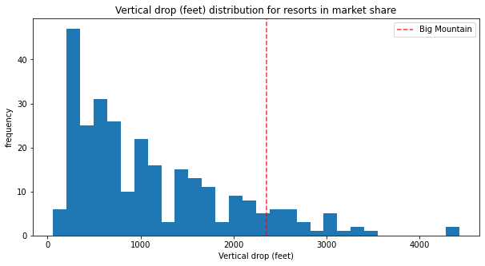

The scenarios of adding a run, increasing vertical drop by 150 feet and installing an additional chair lift would support a ticket increase of $1.99. This would amount to $3,474,638 over the season.